**P. Kiran Kumar**

**191911312**

**POSTMAN**

POST – Insert new data.

PUT – Modify the existing data.

DELETE – Deletes the data.

-------------------------------------------------------------GET------------------------------------------------------------------

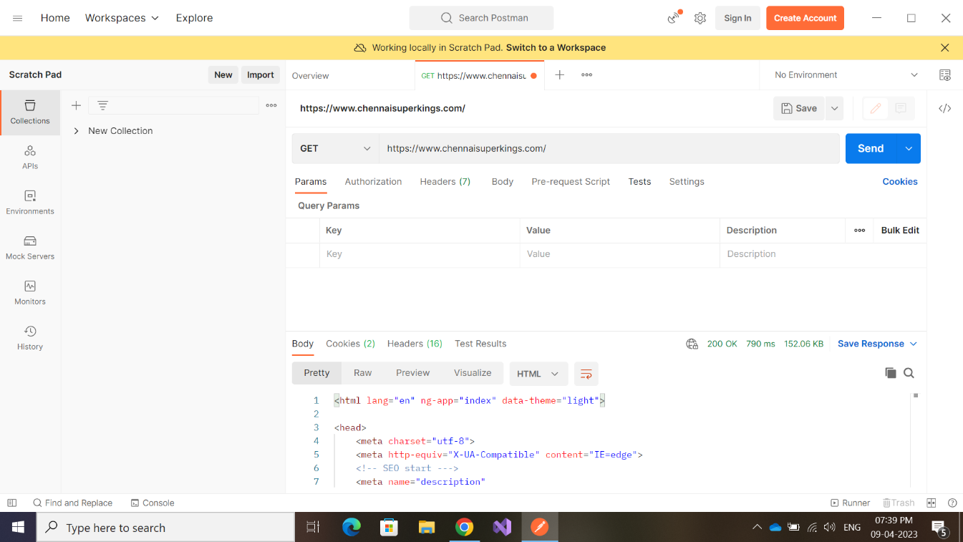

//COLLECTIONS

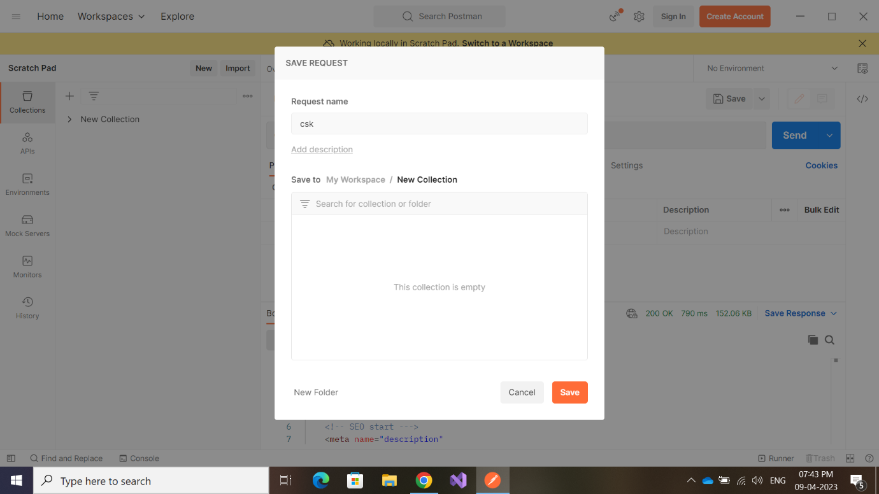

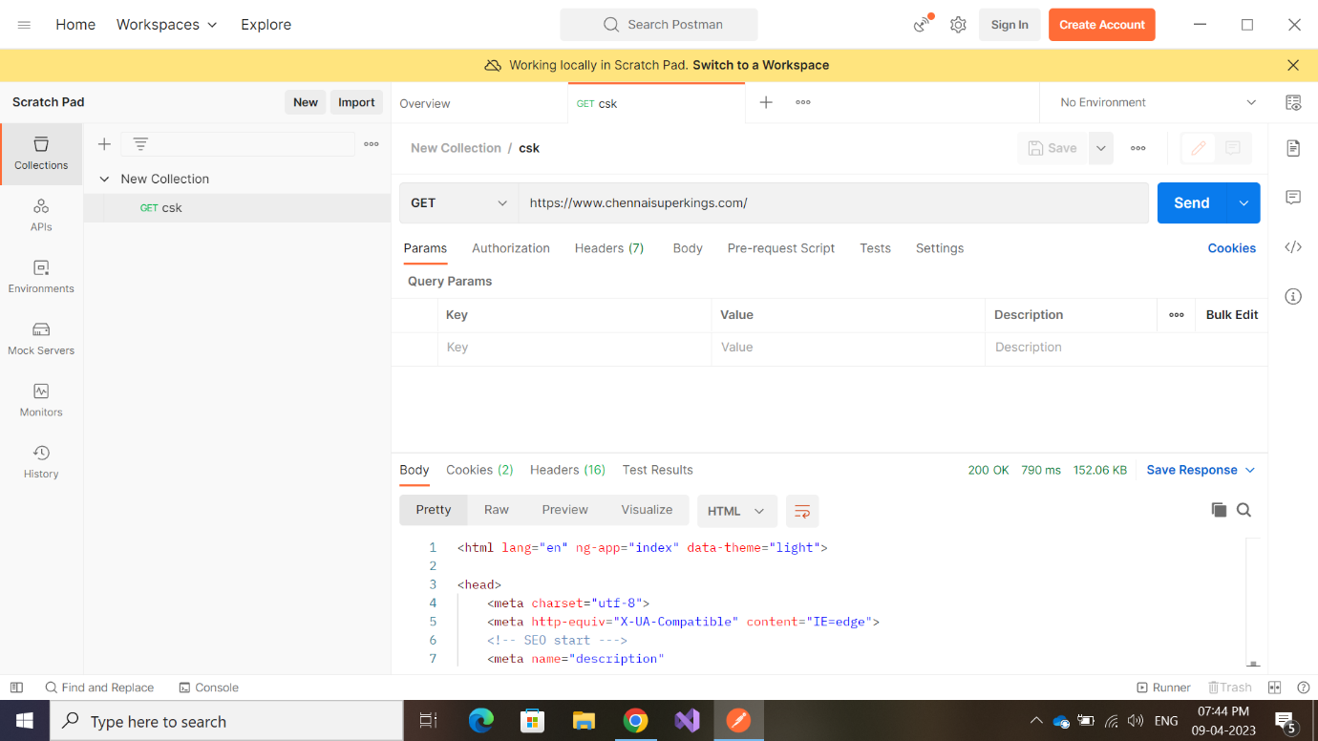

-----------------------------------------------------------GET---------------------------------------------------------------------

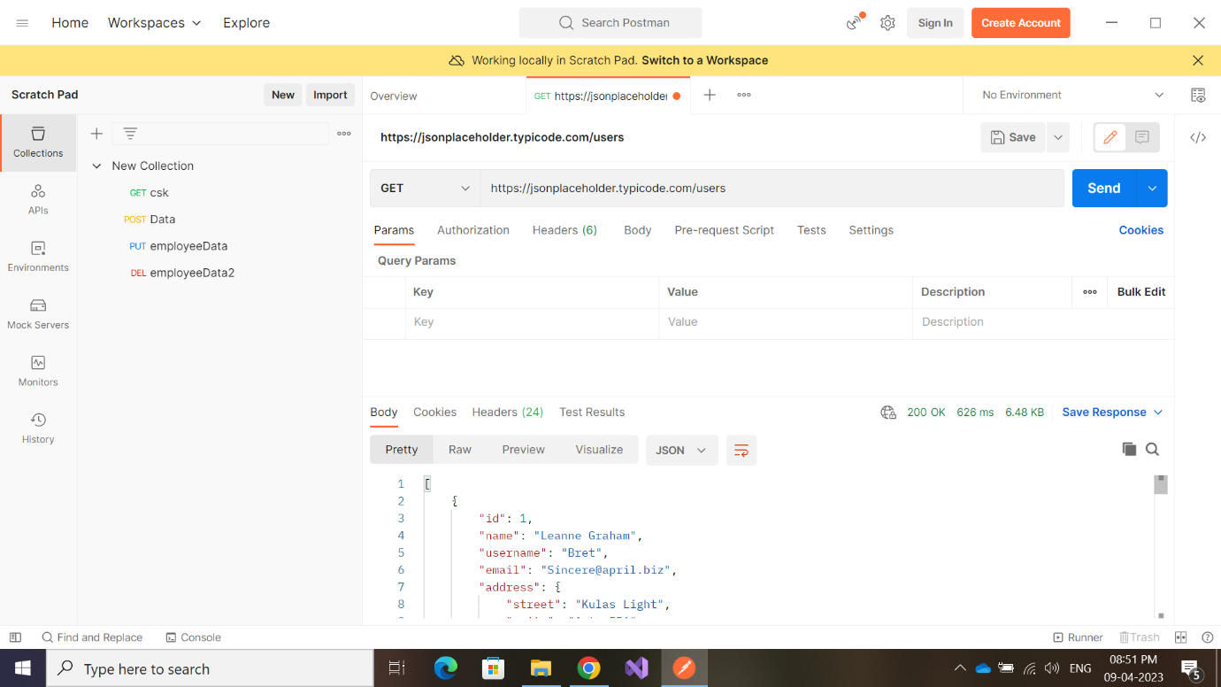

200 OK – successfully retrieved data !

----------------------------------------------------------POST-------------------------------------------------------------------

201 Created – Successfully posted new data !